**Updating Structure/Cost Item Default Factors**

The References page 'List of Structure/Cost Item Default Factors' displays all the structures, and the cost item factors defined by the GSI Cost Tool 'super user'.

If a new Cost Item needs to be added to a Structure, or the default factors need to be updated for a Cost Item, the admin page 'Structure Cost Item Default Factors' can be used. In the screen shot below, the structure 'Stormwater Wetland' does not have any default Area for either Wetland Planting, or Permanent Cover.

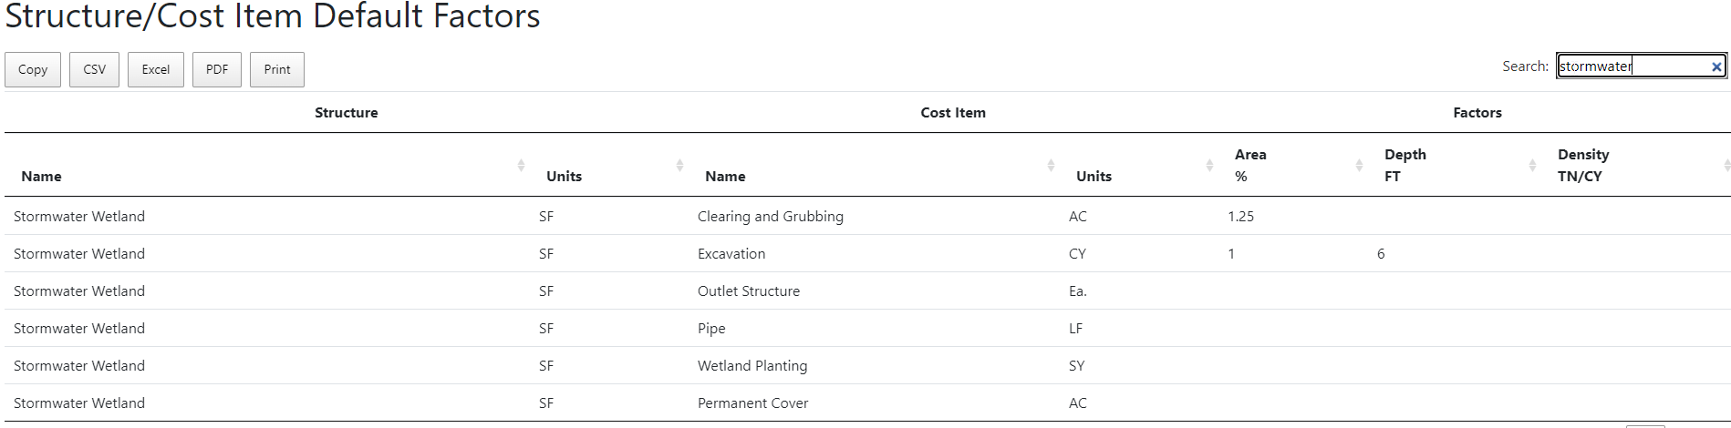

Note: New values are entered using the 'GSI Cost Tool Admin Page', which is only available to users who have been granted 'superuser' status. When a superuser logs into the GSI Cost Tool, the menu in the upper right corner of the screen has 3 options. Use the first option to open the 'GSI Cost Tool Admin Page'

**Select structure cost item default factors to change**

On the GSI Cost Tool Admin Page the administrator can add, edit, and delete data. The administrator can select any option by selecting the name of the option, or the 'Change' menu button.

To update the Structure/Cost Item Default Factors, select that option from the Site administration list. To make it easier to work with the data, there is a list of all the Structures on the right side that can be used to filter for a single Structure. For the example, select Stormwater Wetland from the filter, and the page will automatically filter the Cost Items for that Structure

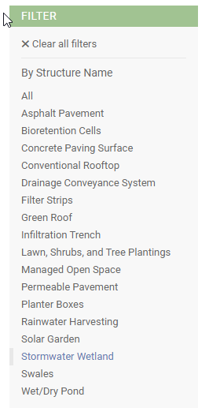

To update the Default Factors, click the row you want to change. In this example, the Wetland Planting row

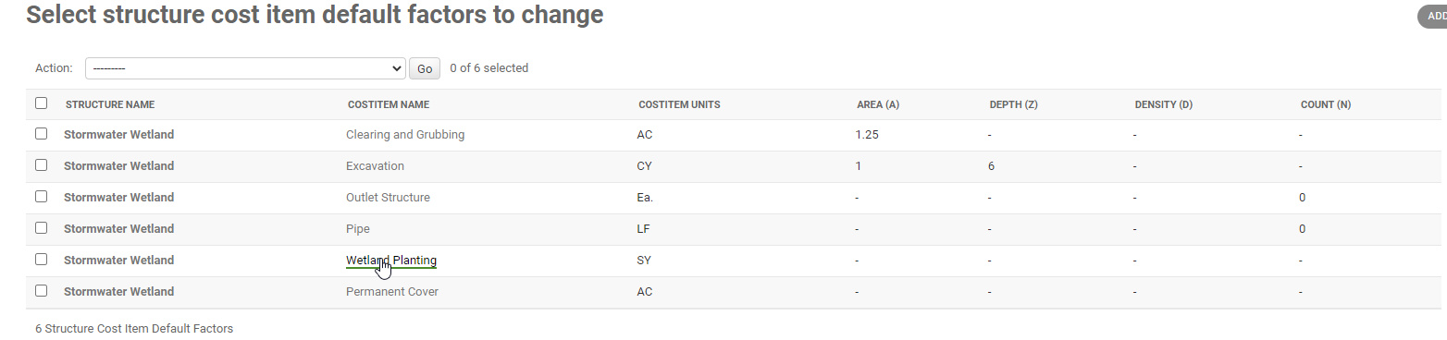

In the screen that opens, enter the new Default Factors for the cost item. In this example, we might set the default Area to be .50 – as a default we estimate that wetland plantings cover 50% of a stormwater wetland (another 25% will be permanent cover (see second image below), and the remaining 25% is open water) Then hit the SAVE button on the lower right corner of the screen.

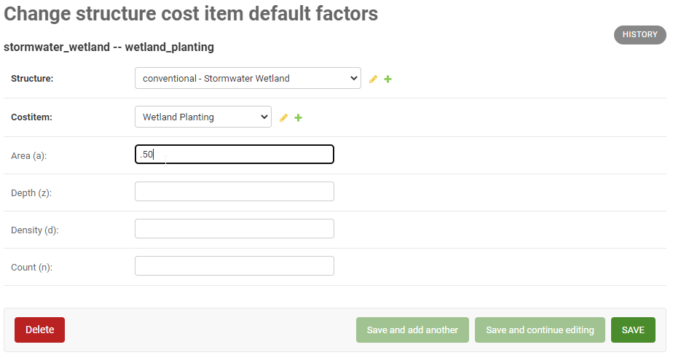

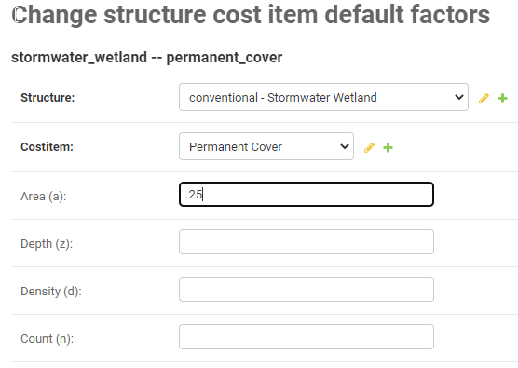

On the list of Cost Items, the updated entry will be shown in the list.

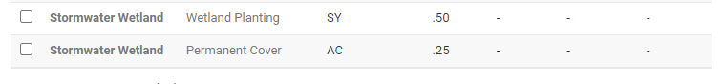

And the update will be reflected in the References list

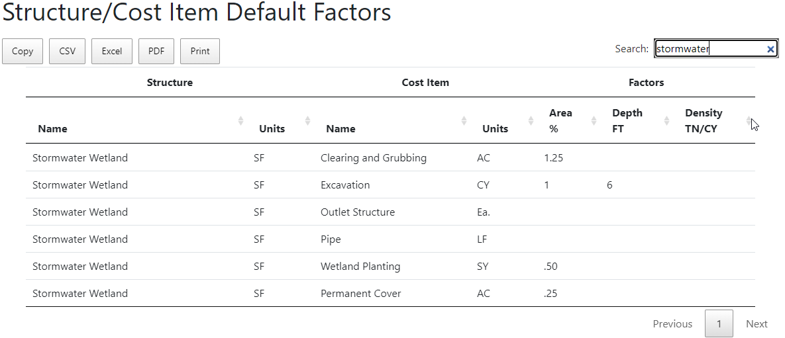

**Review in GSI Cost Tool**

In the GSI Cost Tool itself, the updated factors will be displayed in the Structure Cost Item User Factors

